**Clean up of CMTS Resources**

1. Make sure you don’t have Amazon inspector activated.
2. Delete instances created in AWS.
   1. Select all the instances and Click Instance State -> Terminate Instance

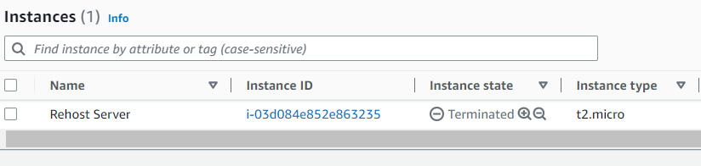

* 1. Release the Elastic IP

1. Delete the RDS Instance.
   1. Select the DB Instance and click on Actions -> Delete.

* 1. Uncheck “Create final snapshot?” and “Retain automated backups”.

* 1. Check “I acknowledge that upon instance deletion, …..” and enter “delete me”.

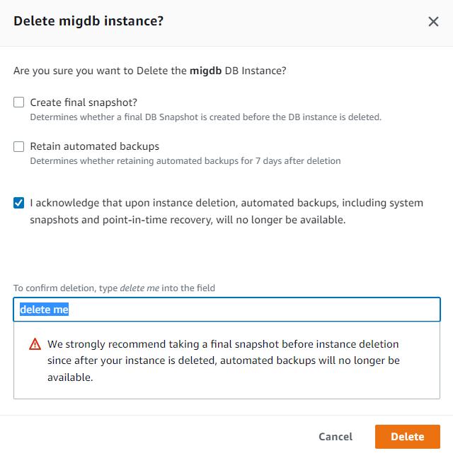

* 1. Then click Delete.

1. Delete AWS DMS
   1. Delete the Database Migration Tasks. Select the tasks and click Actions -> Delete and confirm.

* 1. Delete the Endpoints. Select the endpoints and click Actions -> Delete and confirm.

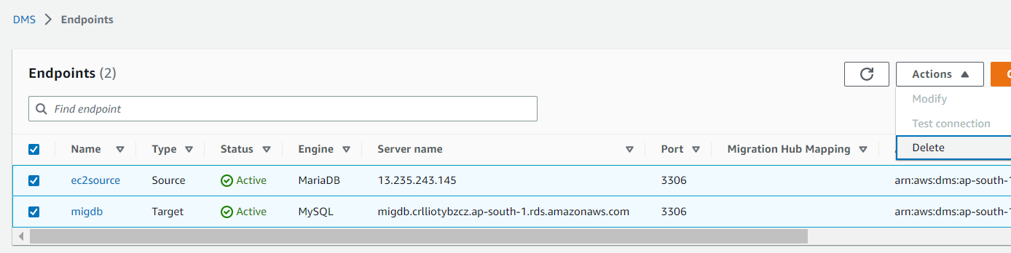

* 1. Delete the Replication instances. Select the instances and click Actions -> Delete and confirm.

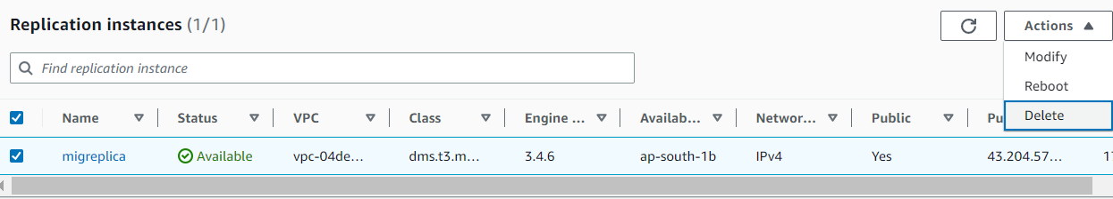

1. Delete Azure resources.
   1. Select the Resource group and delete.

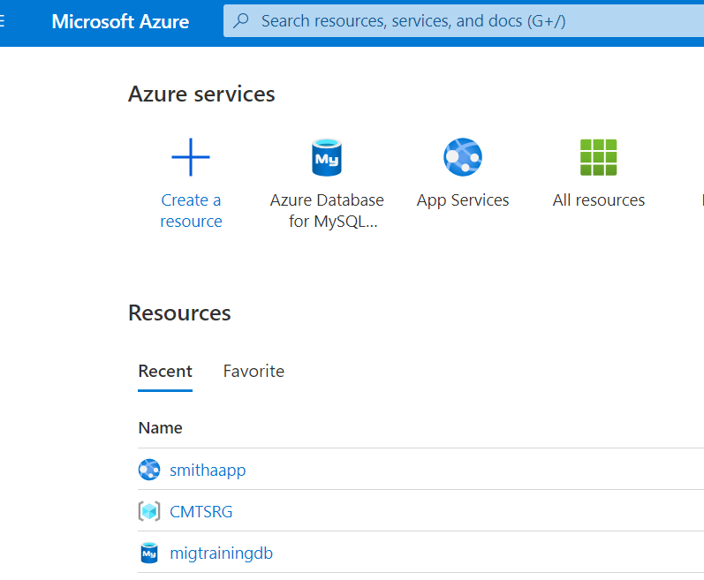

* 1. Click “Delete resource group”.

* 1. Refresh the Home page and make sure all the resources are deleted.

